Circular–Freeform Open Shapes
# Source: AI Source: Provided by: [Data Path: Persons Table -> ID Column: 1, Name_En Column: Motasem Essam] -> From: [ChatGPT] on [7/25/2026]
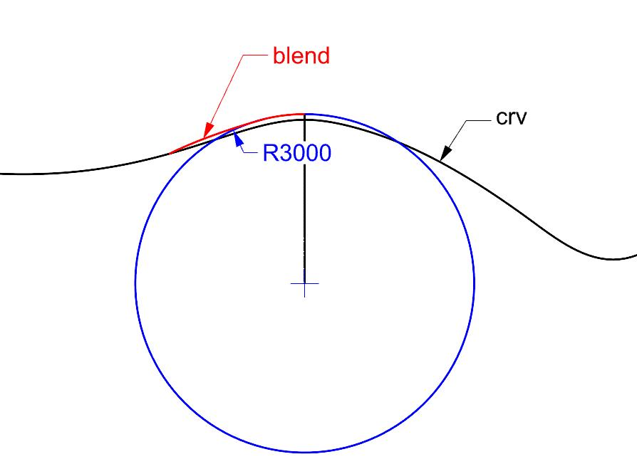
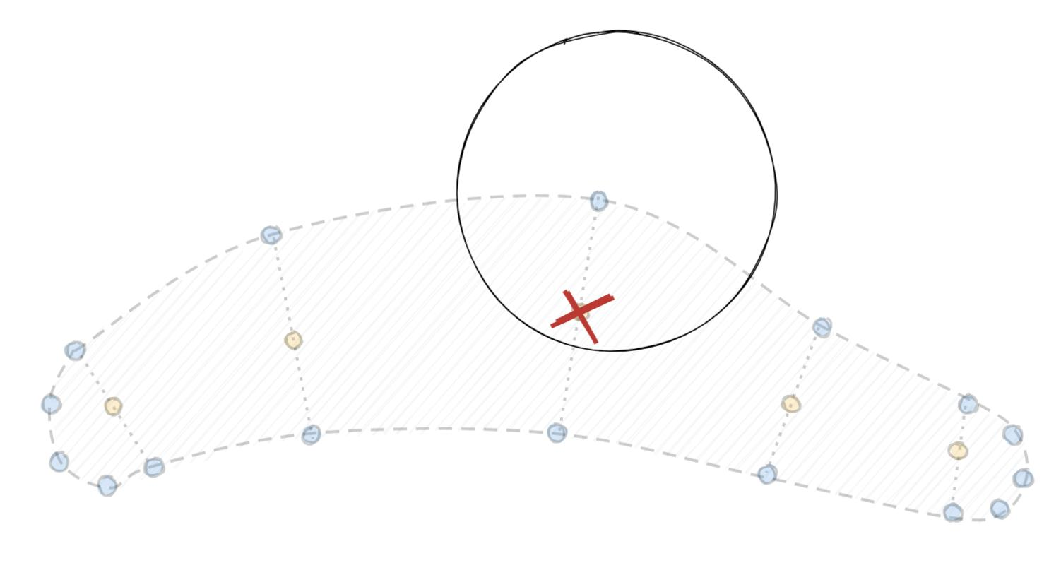
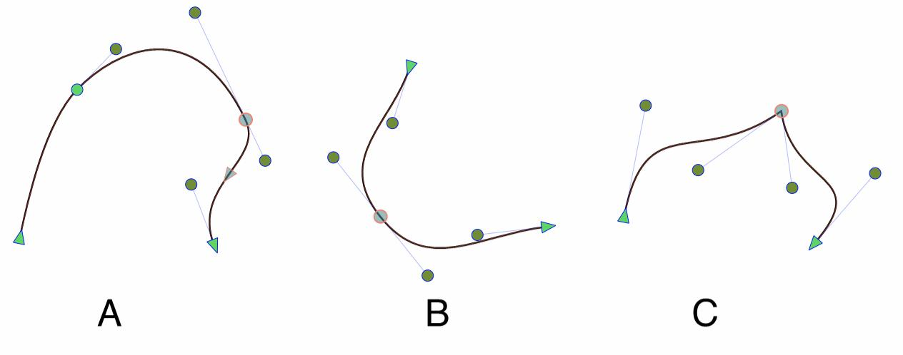

Definition
# Source: AI Source: Provided by: [Data Path: Persons Table -> ID Column: 1, Name_En Column: Motasem Essam] -> From: [ChatGPT] on [7/25/2026]
A Circular–Freeform Open Shape is an open mixed shape that combines one or more circular arcs with freely designed curved portions that are not restricted to a standard geometric form.
$$\boxed{\text{Circular–Freeform Open Shape}=\text{Circular Arc(s)}+\text{Freeform Curve(s)}+\text{Open Boundary}}$$
The shape remains open because its path does not completely close.

Characteristics
# Source: AI Source: Provided by: [Data Path: Persons Table -> ID Column: 1, Name_En Column: Motasem Essam] -> From: [ChatGPT] on [7/25/2026]
A Circular–Freeform Open Shape:
- Is open.
- Contains at least one circular arc.
- Contains at least one freeform curved portion.
- Combines regular circular geometry with freely controlled curvature.
- Has two or more endpoints.
- Does not enclose an area by itself.
- Does not require the freeform portion to follow a mathematical equation.
- May be smooth, irregular, wavy, or artistic.
- May be symmetric or asymmetric.

Types of Circular–Freeform Open Shapes

1. Simple Circular–Freeform Open Shape
# Source: AI Source: Provided by: [Data Path: Persons Table -> ID Column: 1, Name_En Column: Motasem Essam] -> From: [ChatGPT] on [7/25/2026]
A simple open path combining one circular arc with one freely designed curved portion.
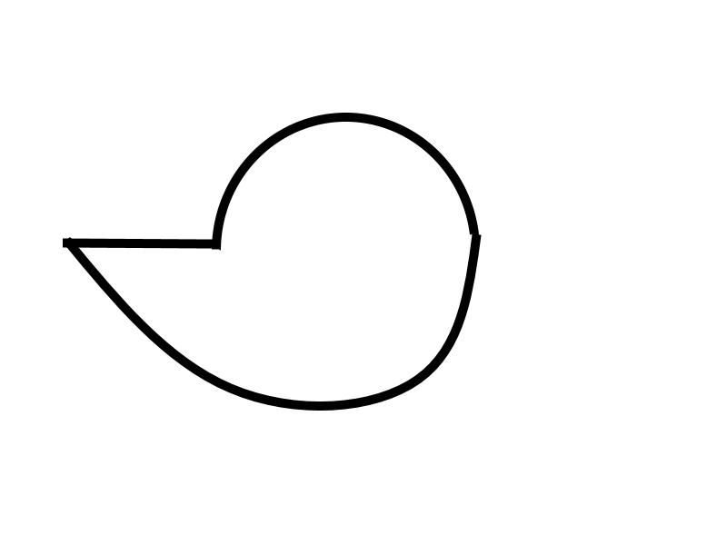
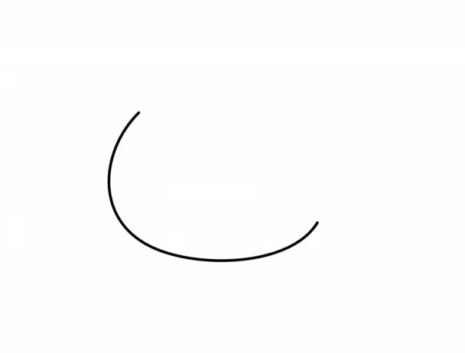
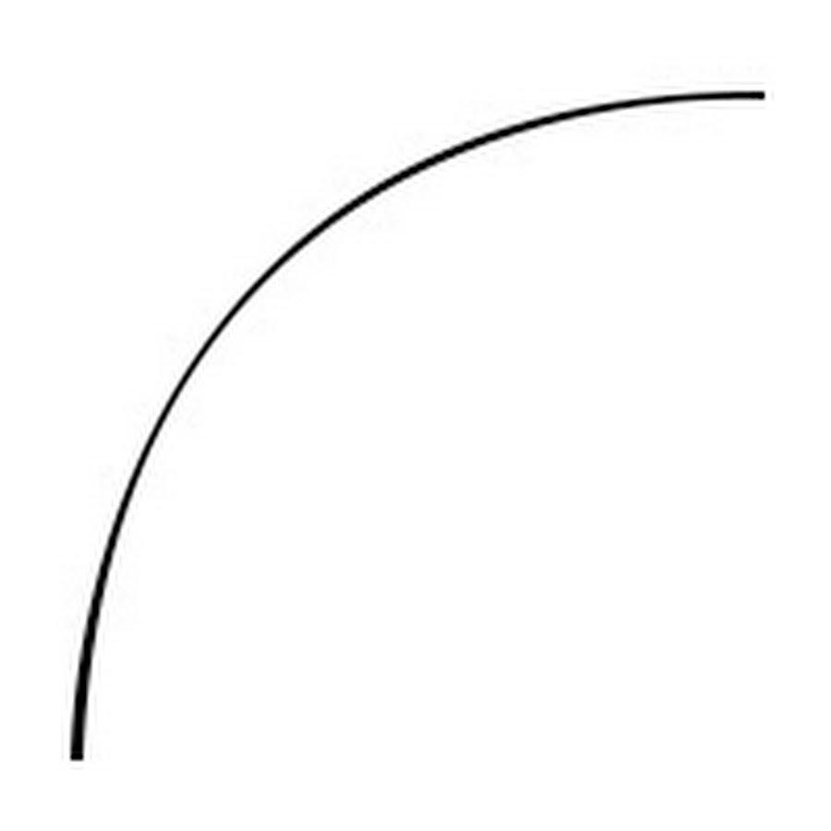

2. Single-Arc Circular–Freeform Open Shape
# Source: AI Source: Provided by: [Data Path: Persons Table -> ID Column: 1, Name_En Column: Motasem Essam] -> From: [ChatGPT] on [7/25/2026]
An open path containing one circular arc and a freeform curve.
This is one of the simplest mixed configurations.
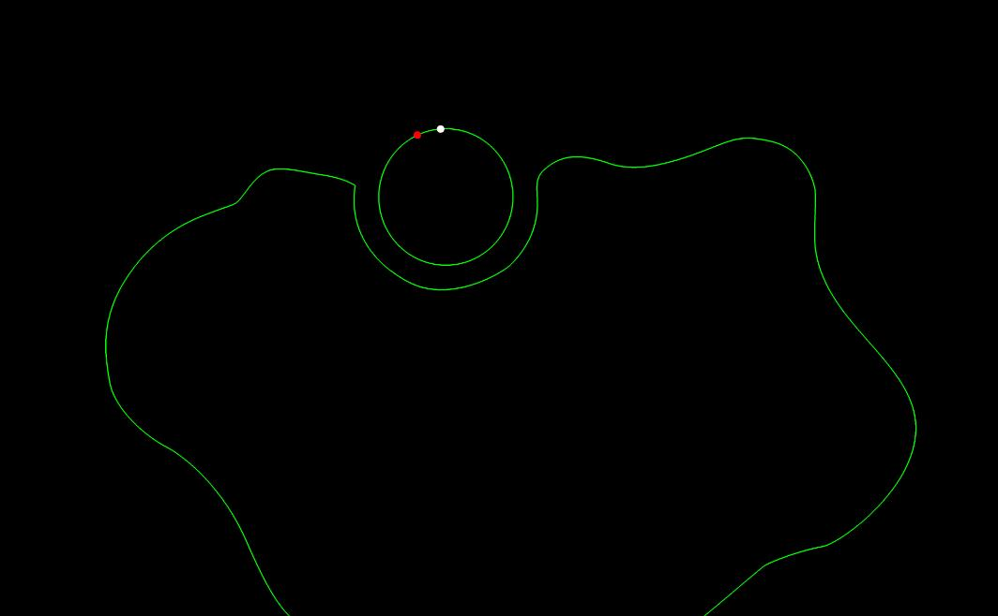
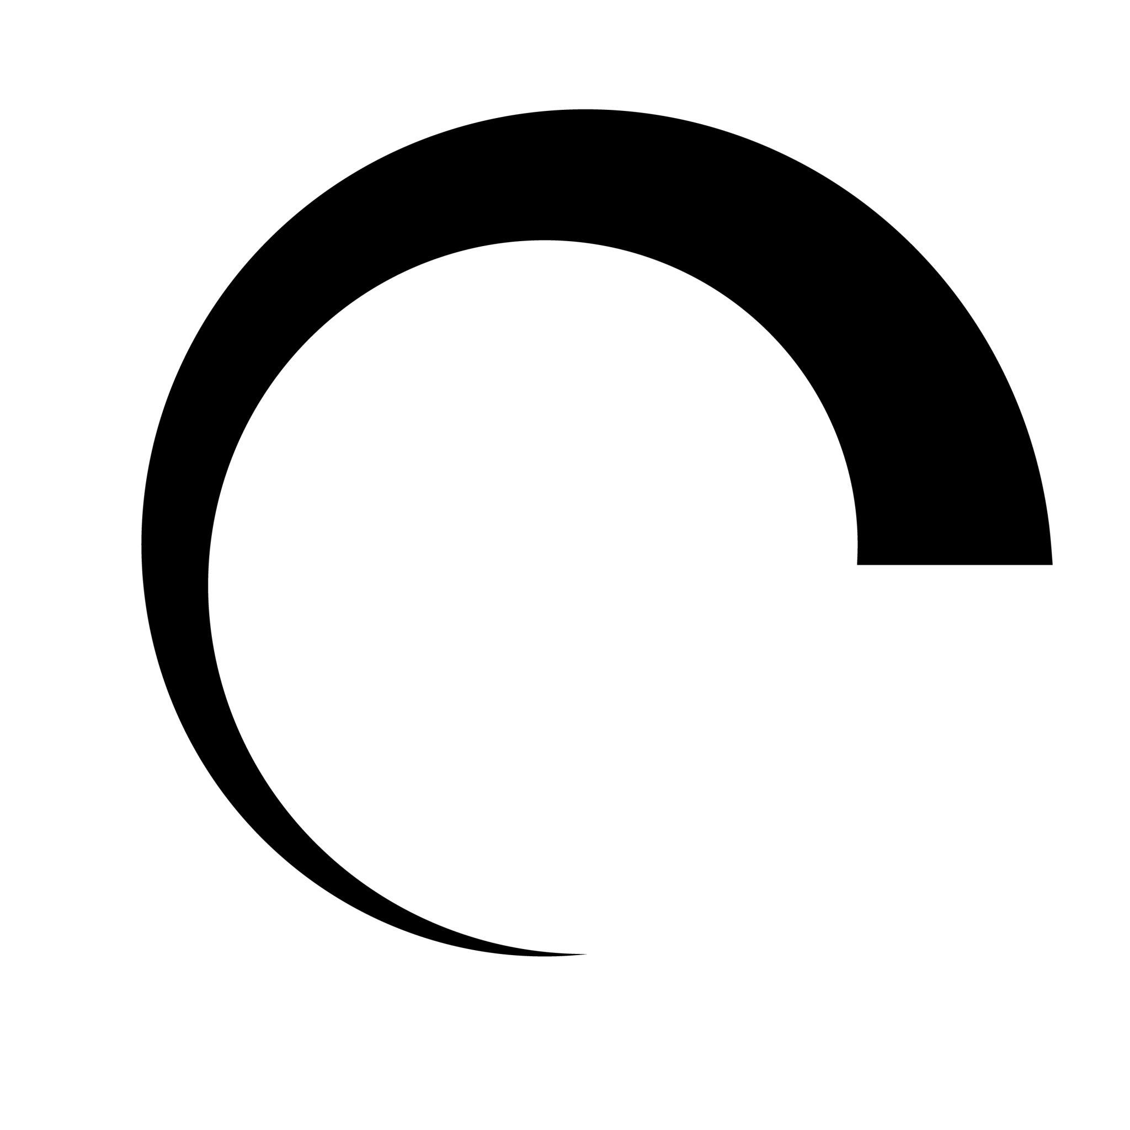

3. Multi-Arc Circular–Freeform Open Shape
# Source: AI Source: Provided by: [Data Path: Persons Table -> ID Column: 1, Name_En Column: Motasem Essam] -> From: [ChatGPT] on [7/25/2026]
An open path containing multiple circular arcs separated or connected by freeform curves.
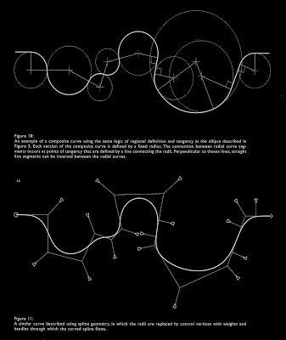
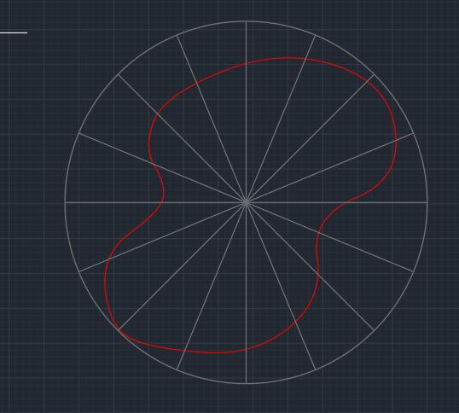
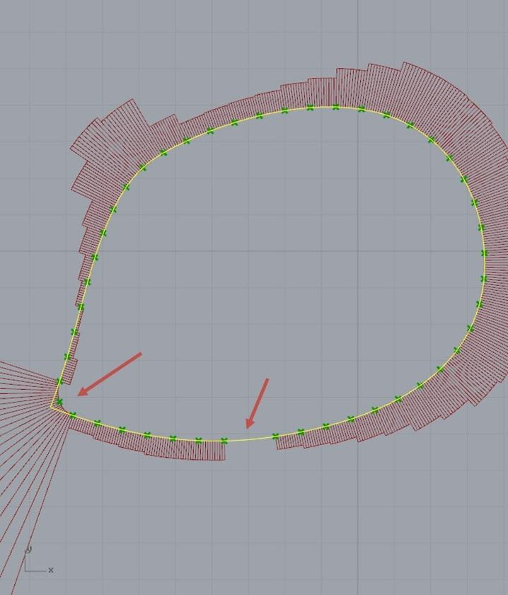
The circular arcs may have different radii.

4. Smooth Circular–Freeform Open Shape
# Source: AI Source: Provided by: [Data Path: Persons Table -> ID Column: 1, Name_En Column: Motasem Essam] -> From: [ChatGPT] on [7/25/2026]
The circular arcs connect smoothly to the freeform portions.
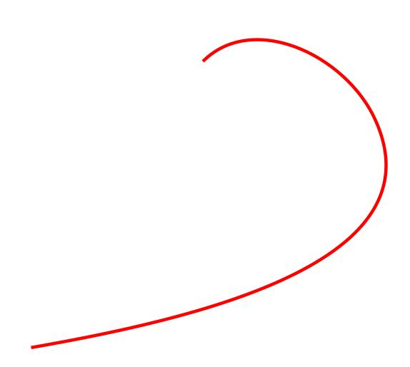
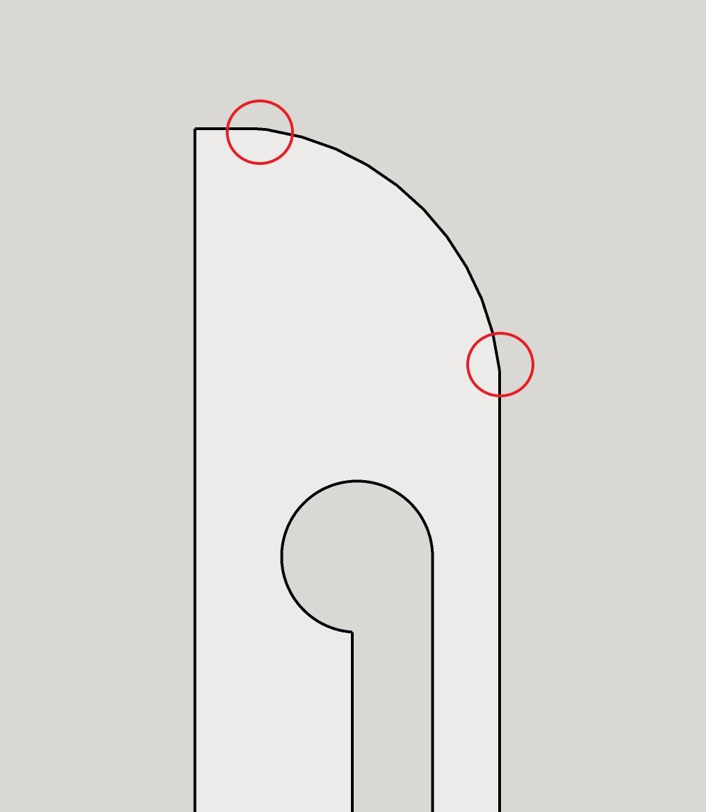
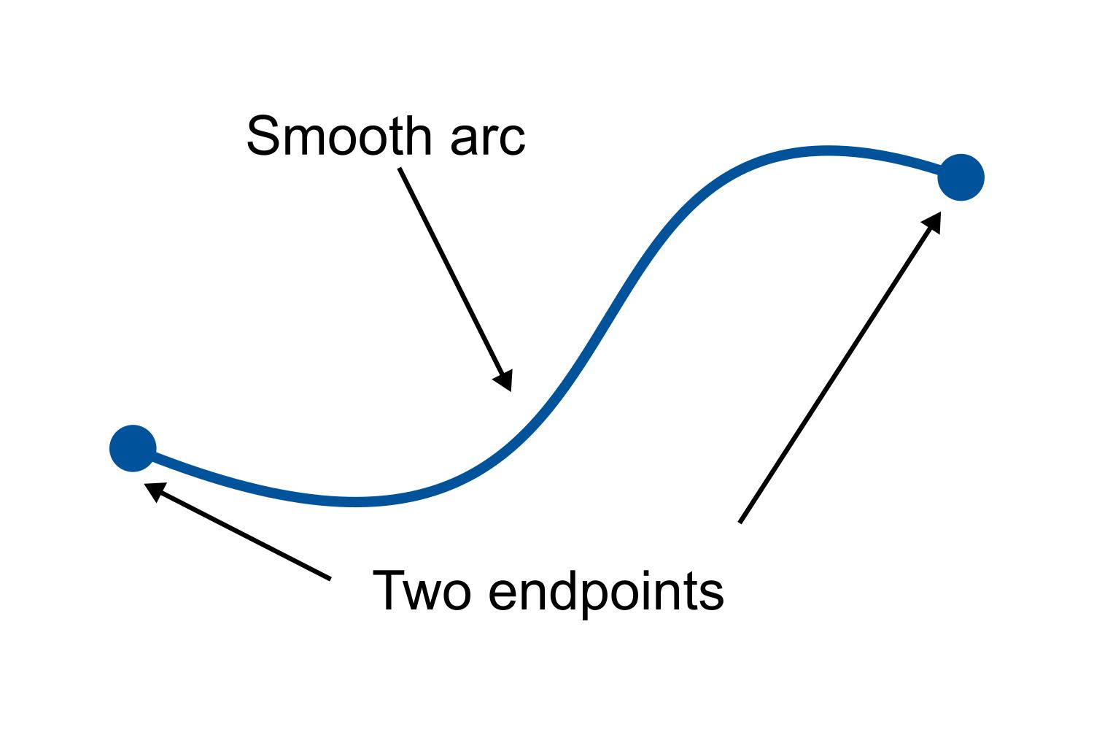
The transitions do not contain obvious sharp corners.

5. Cornered Circular–Freeform Open Shape
# Source: AI Source: Provided by: [Data Path: Persons Table -> ID Column: 1, Name_En Column: Motasem Essam] -> From: [ChatGPT] on [7/25/2026]
The circular and freeform portions meet with visible changes in direction.
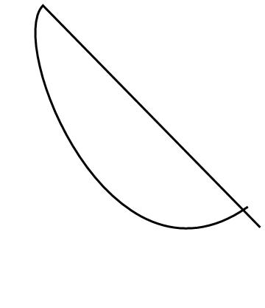
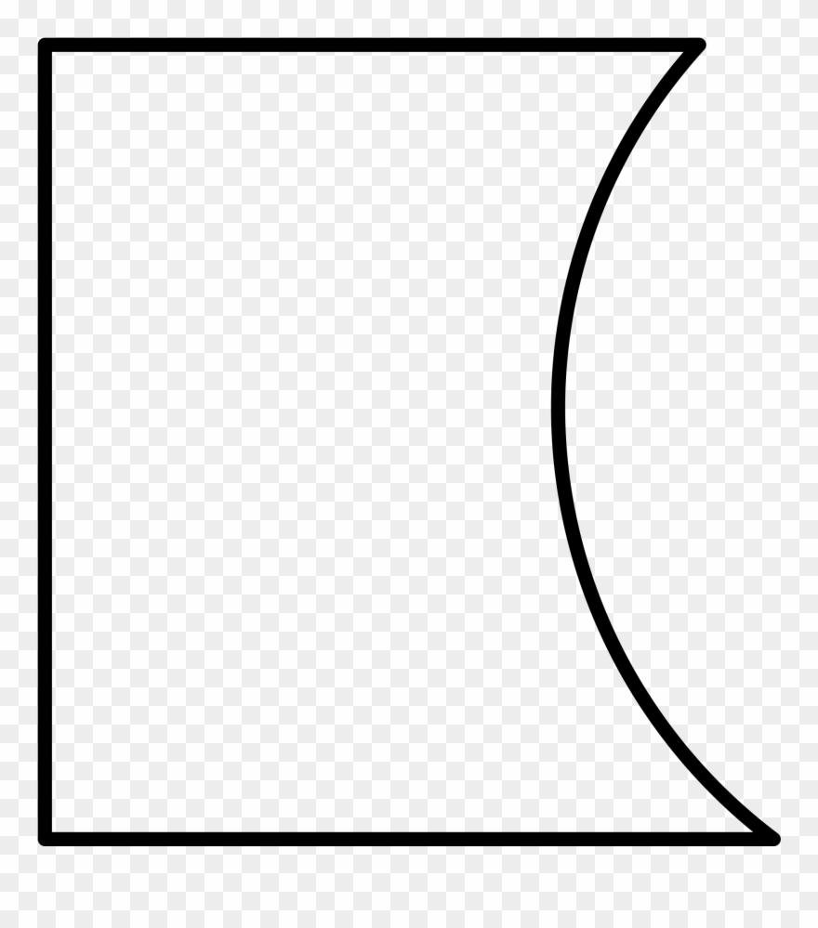
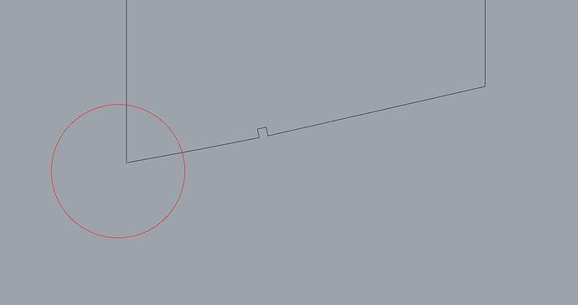
The transition is not tangent or continuously smooth.

6. Wavy Circular–Freeform Open Shape
# Source: AI Source: Provided by: [Data Path: Persons Table -> ID Column: 1, Name_En Column: Motasem Essam] -> From: [ChatGPT] on [7/25/2026]
The freeform portion contains waves or irregular undulations together with circular arcs.
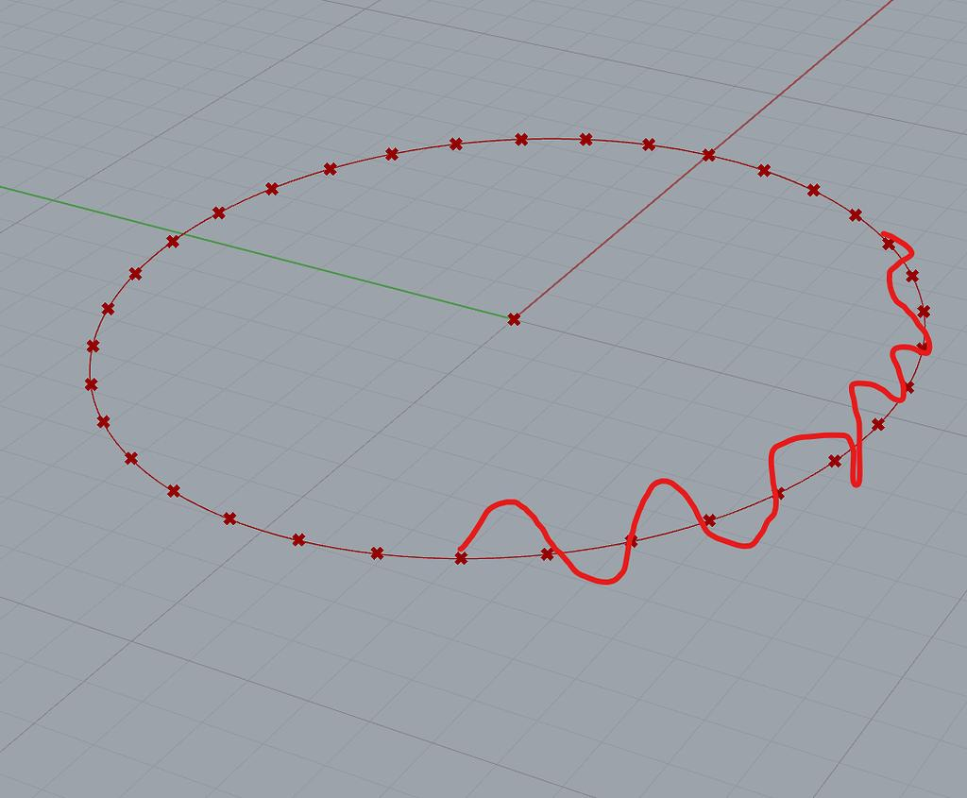
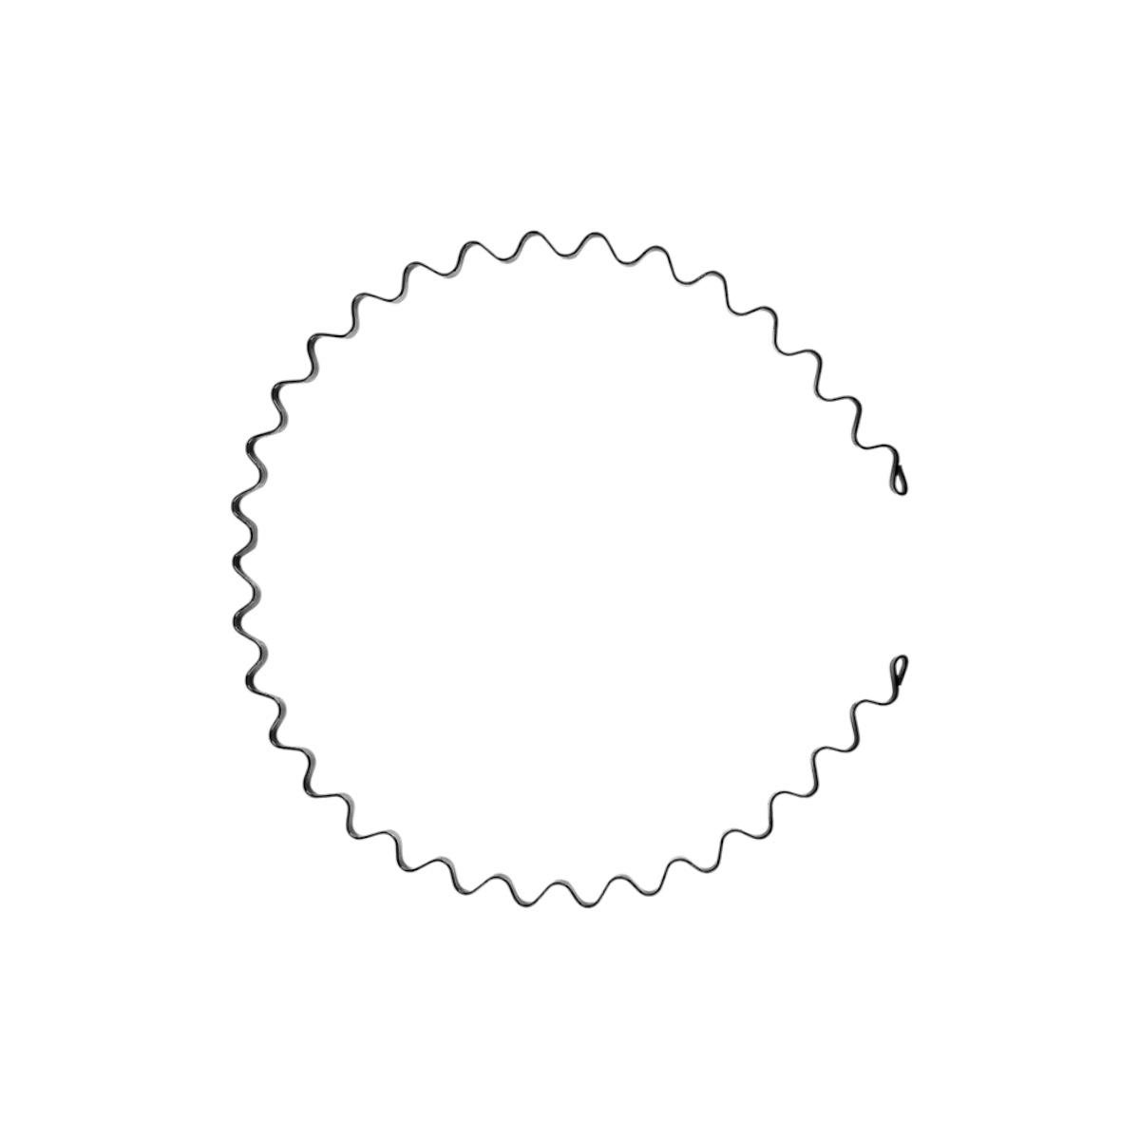
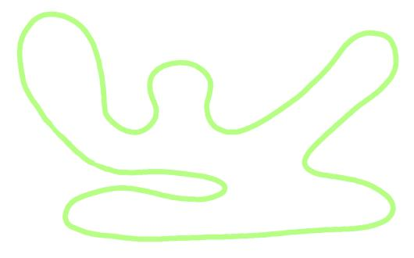
The waves do not have to be periodic or mathematically regular.

7. Spiral-Like Circular–Freeform Open Shape
# Source: AI Source: Provided by: [Data Path: Persons Table -> ID Column: 1, Name_En Column: Motasem Essam] -> From: [ChatGPT] on [7/25/2026]
The freeform portion winds around a region in a spiral-like manner while the shape also contains circular arcs.
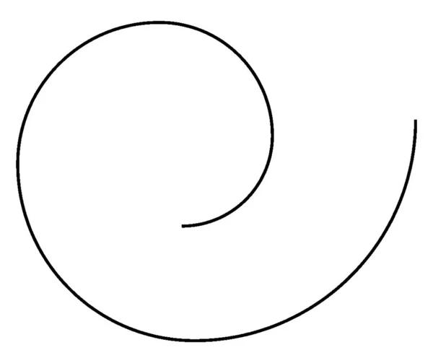
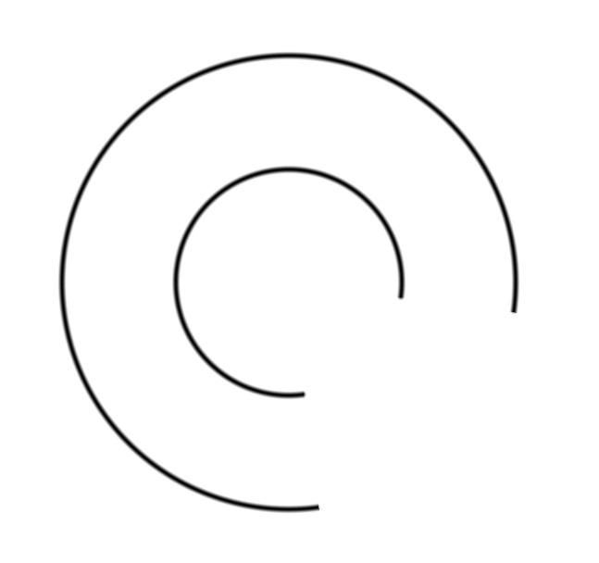
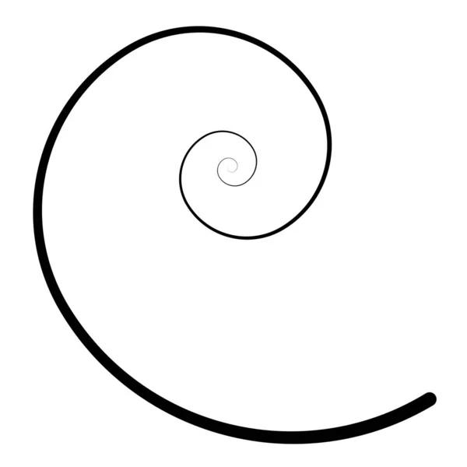
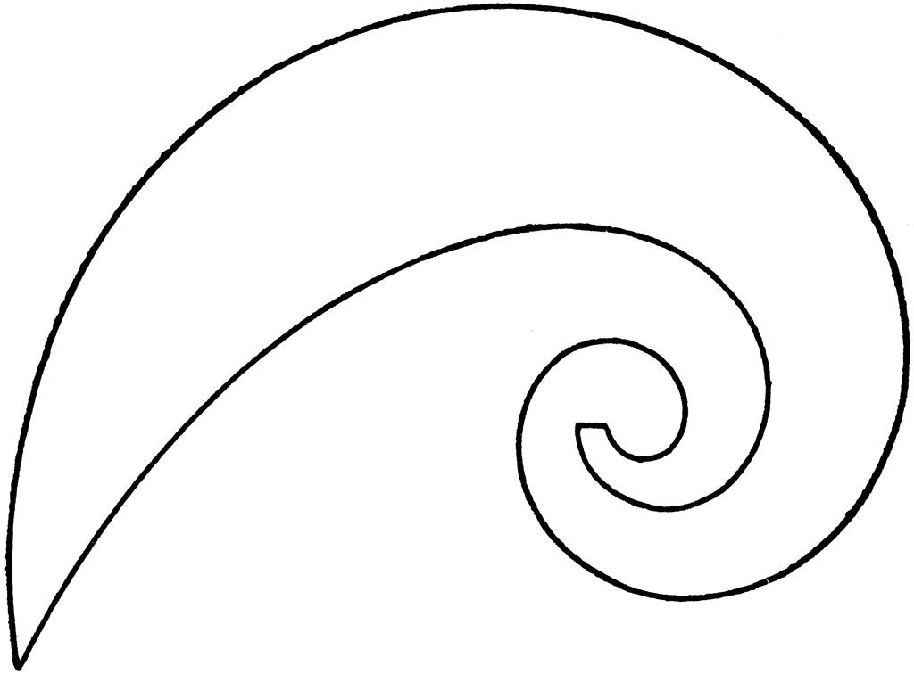
The spiral-like section does not have to follow a strict spiral equation.

8. Symmetric Circular–Freeform Open Shape
# Source: AI Source: Provided by: [Data Path: Persons Table -> ID Column: 1, Name_En Column: Motasem Essam] -> From: [ChatGPT] on [7/25/2026]
The circular and freeform portions are arranged with recognizable symmetry.
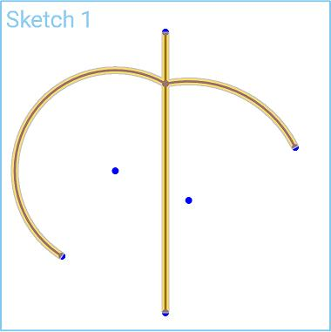
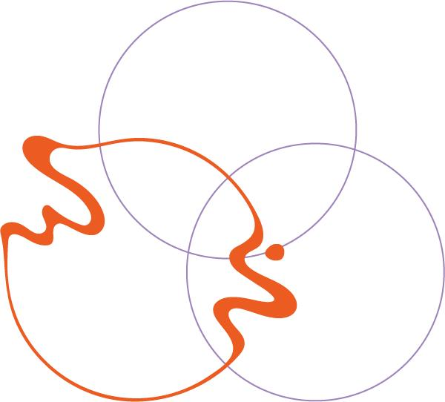
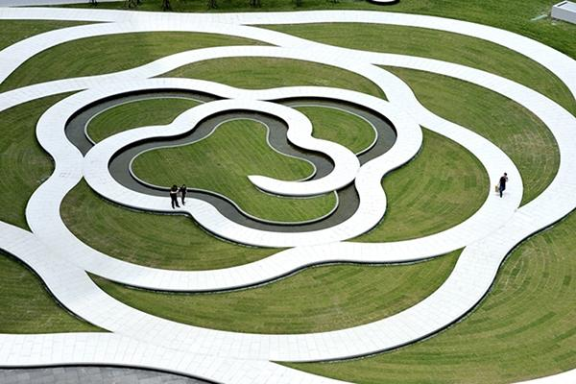
The overall shape can have reflectional or another recognizable symmetry.

9. Asymmetric Circular–Freeform Open Shape
# Source: AI Source: Provided by: [Data Path: Persons Table -> ID Column: 1, Name_En Column: Motasem Essam] -> From: [ChatGPT] on [7/25/2026]
The circular arcs and freeform curves have unequal sizes, positions, or curvature.
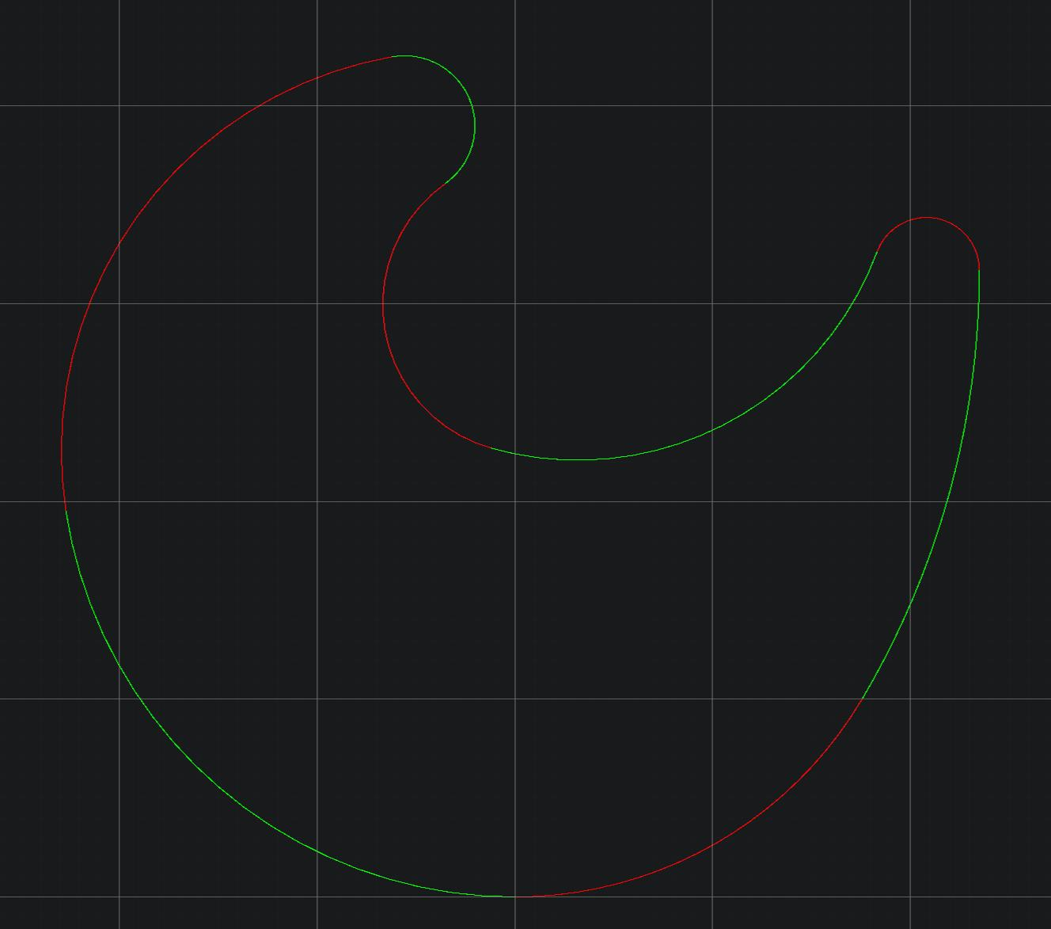
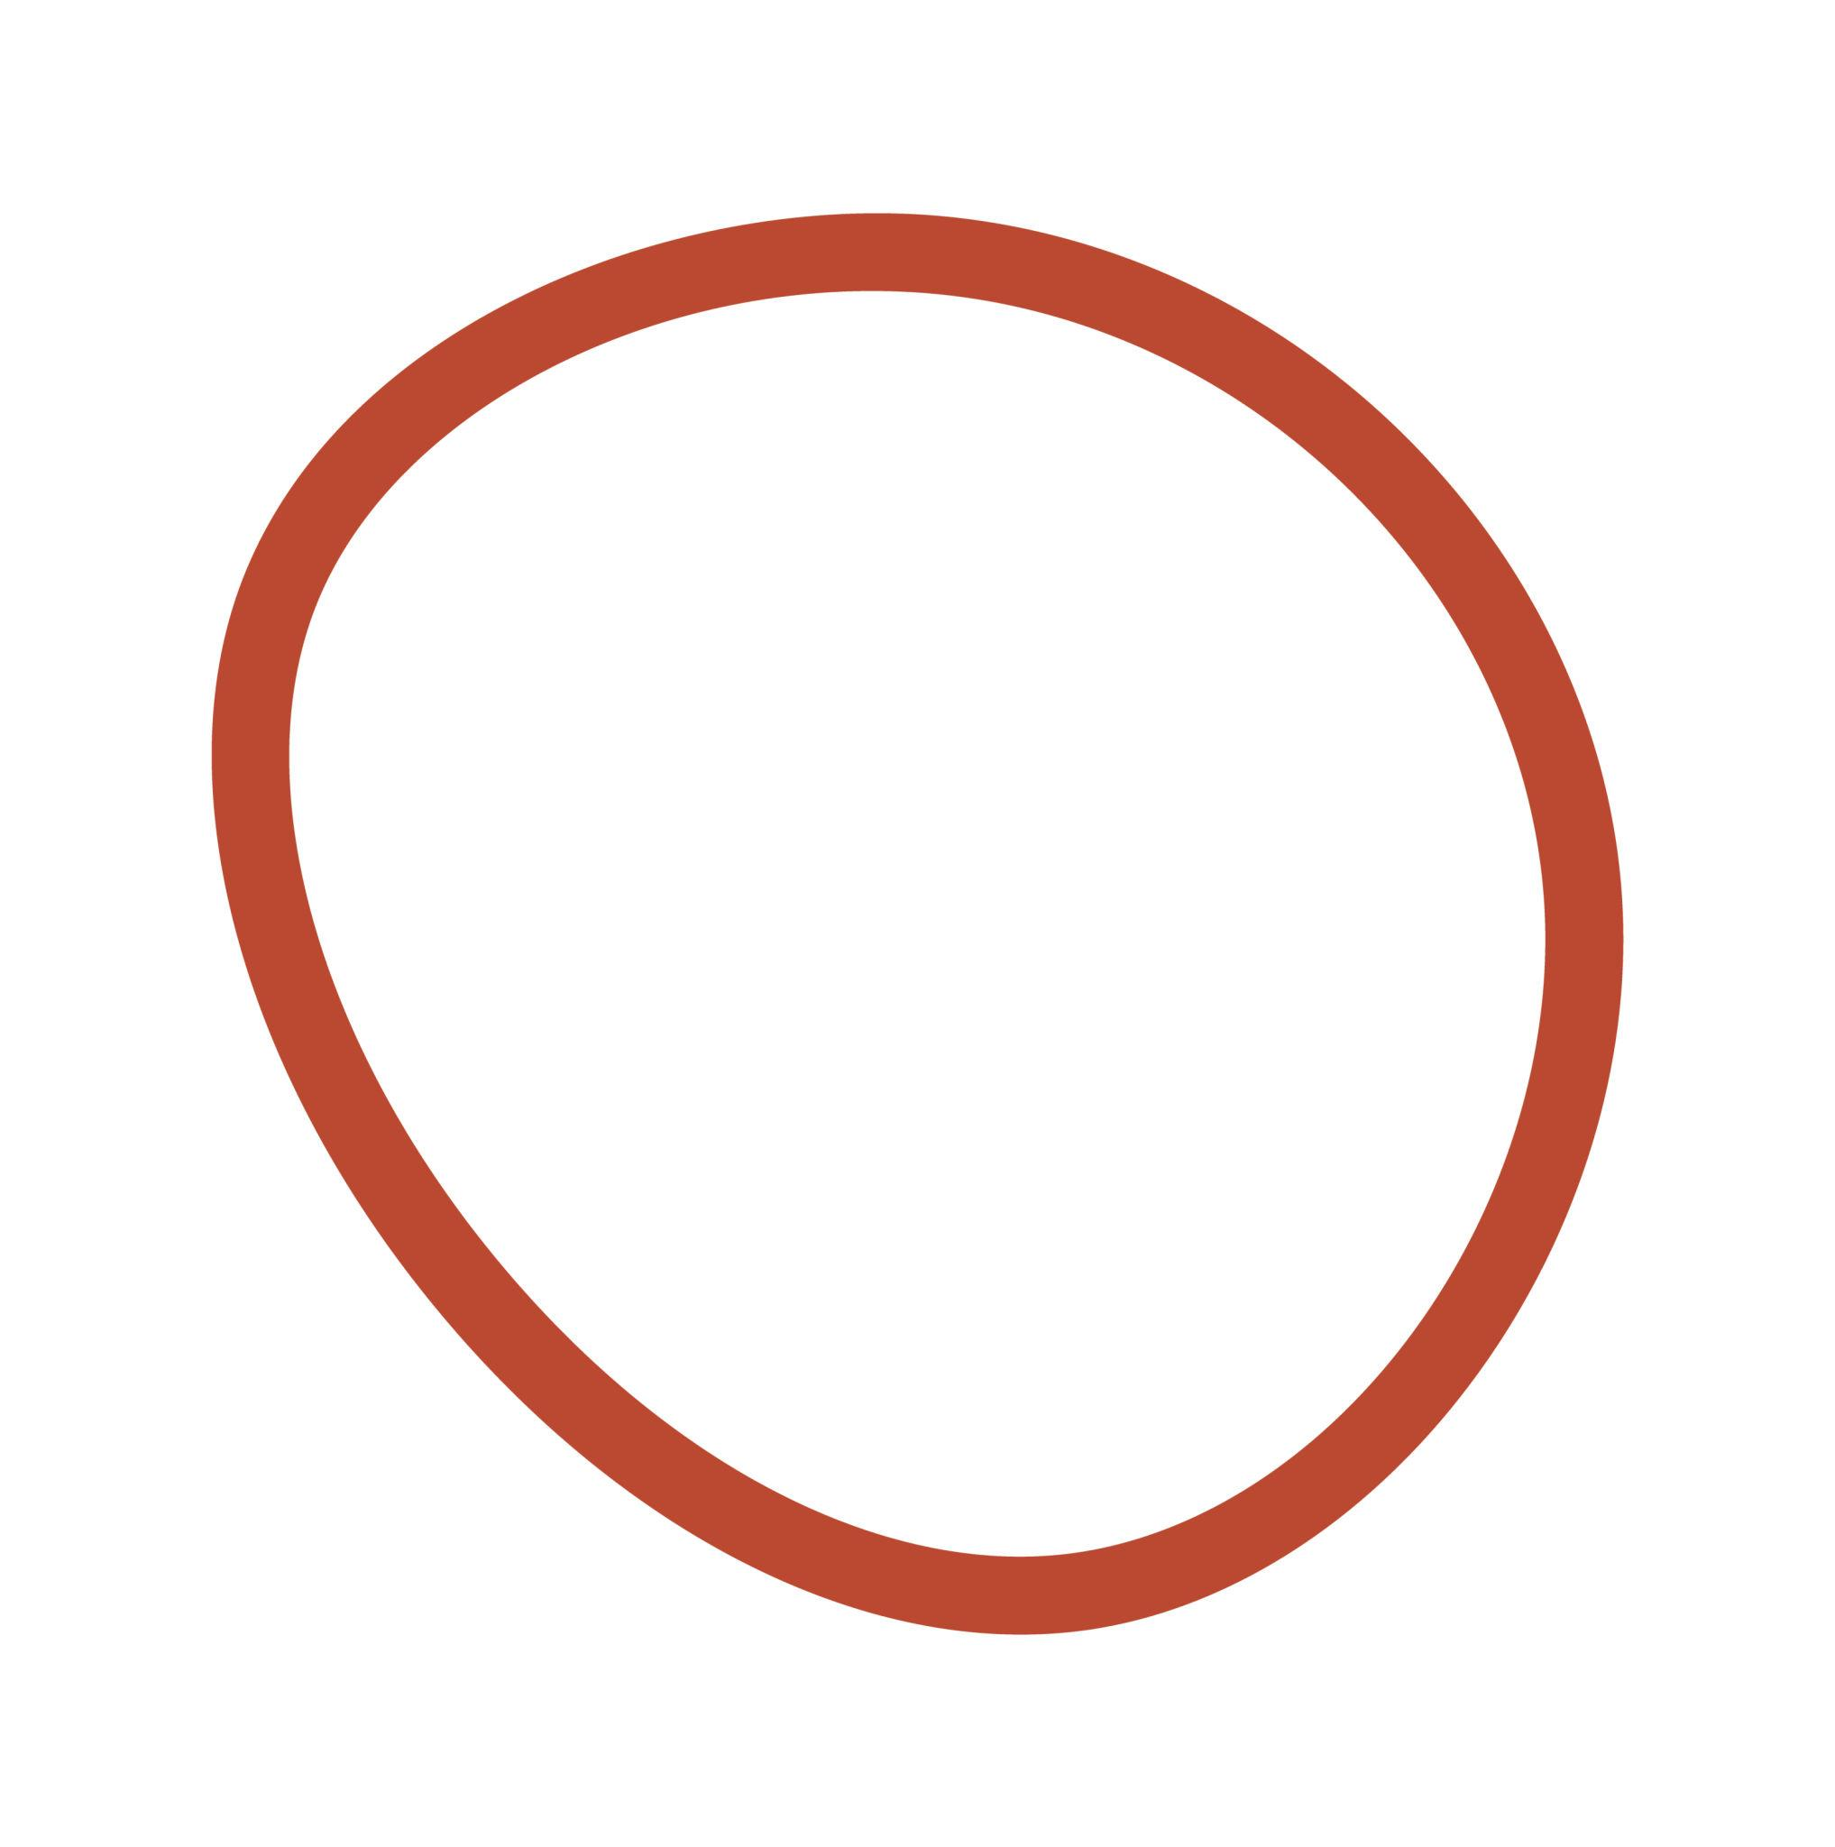
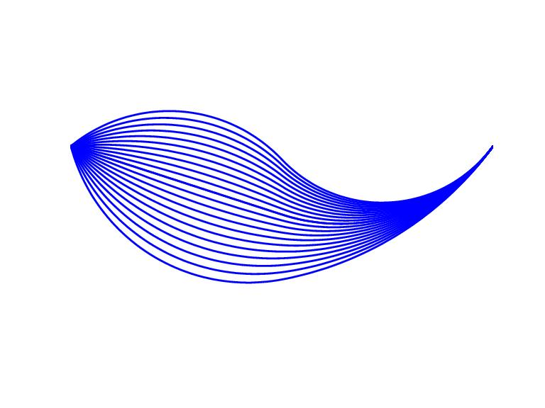
This is useful for classifying irregular mixed shapes.

10. Tangential Circular–Freeform Open Shape
# Source: AI Source: Provided by: [Data Path: Persons Table -> ID Column: 1, Name_En Column: Motasem Essam] -> From: [ChatGPT] on [7/25/2026]
A circular arc connects smoothly to a freeform curve with a common tangent direction.
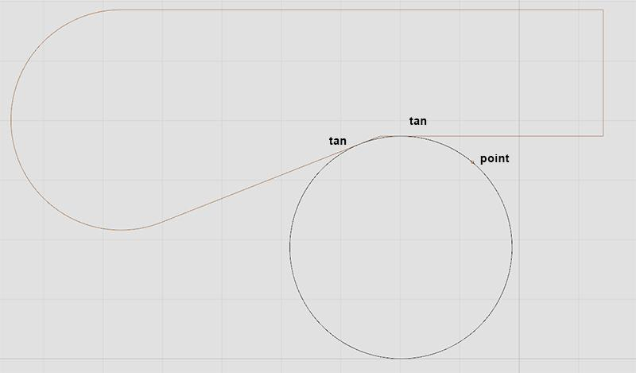
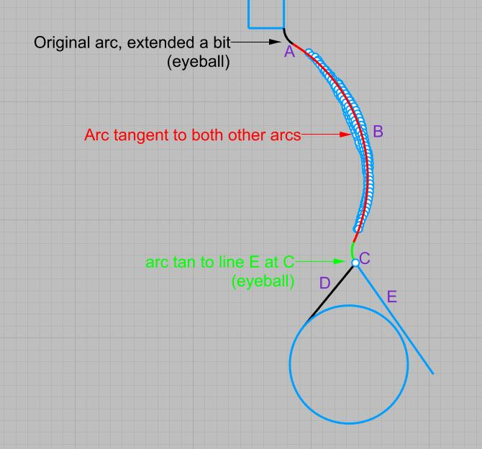
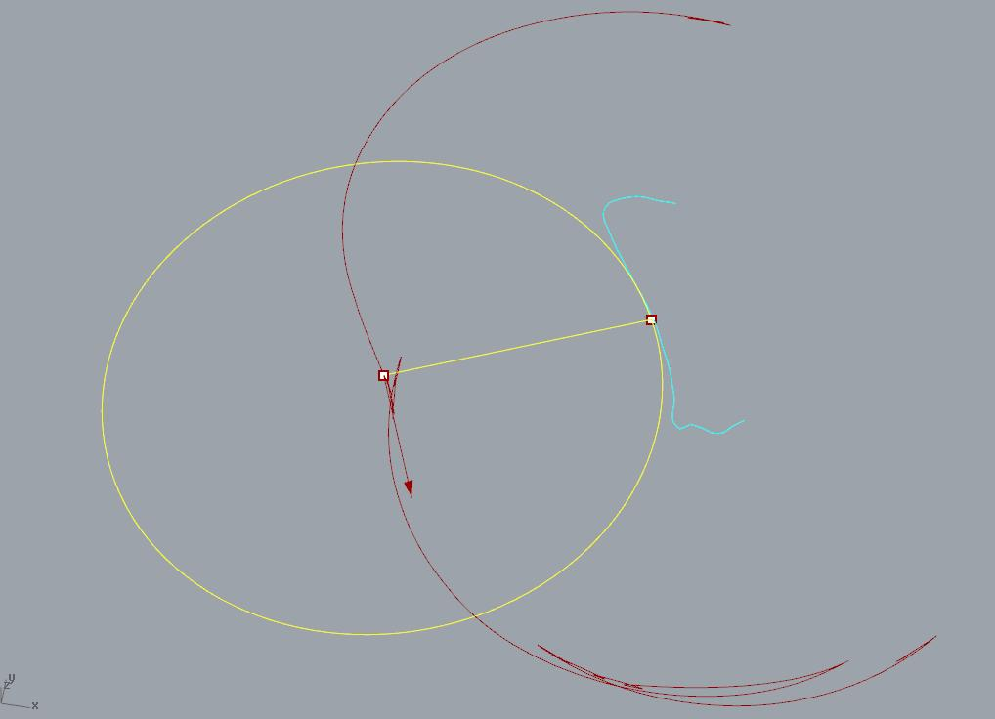
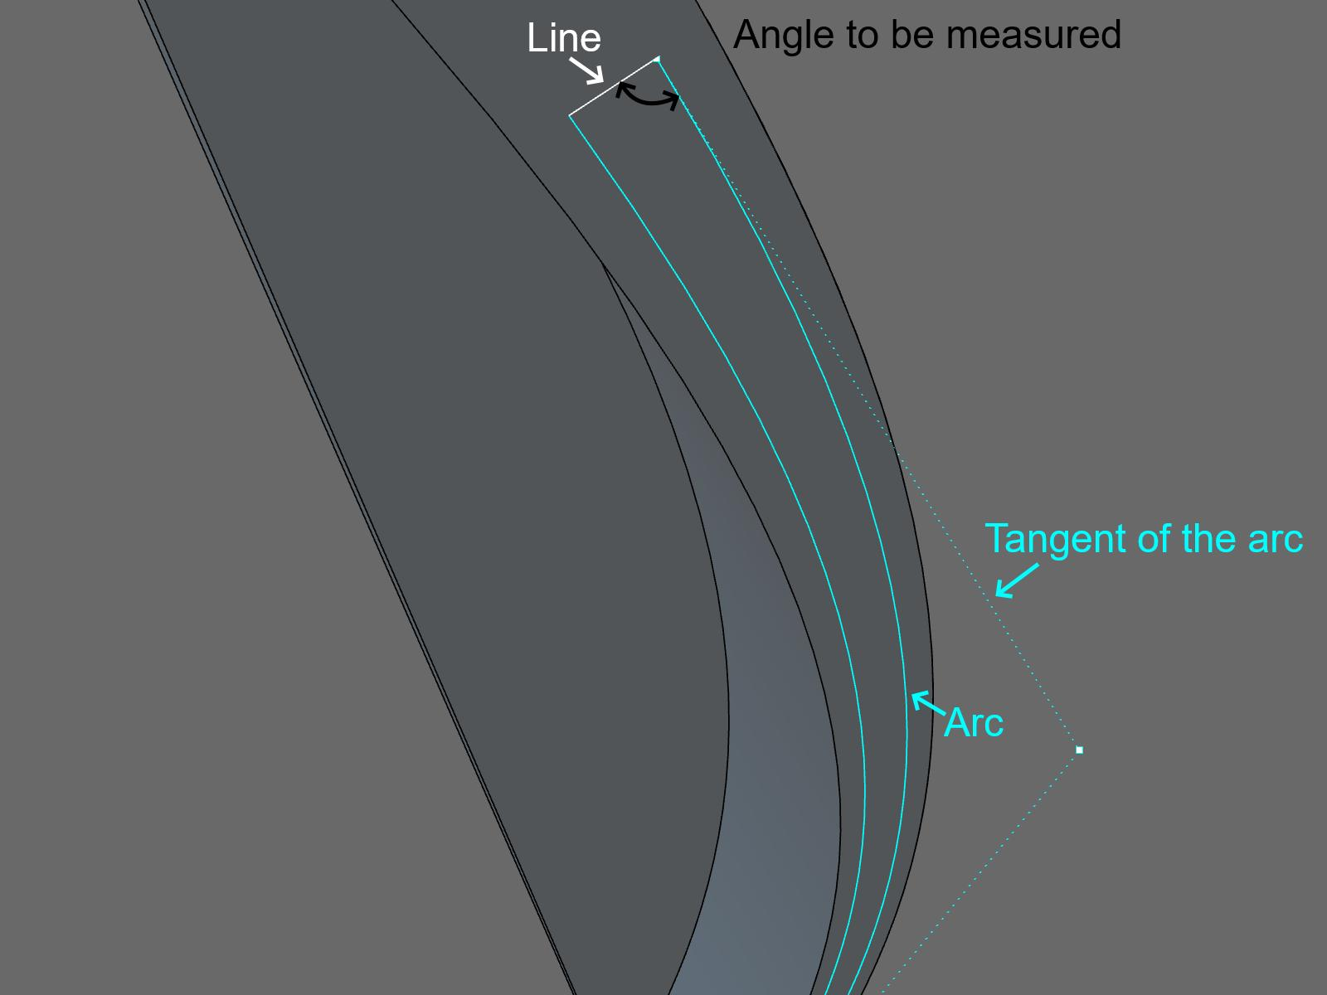
This produces a visually continuous transition between the two portions.

11. Irregular Circular–Freeform Open Shape
# Source: AI Source: Provided by: [Data Path: Persons Table -> ID Column: 1, Name_En Column: Motasem Essam] -> From: [ChatGPT] on [7/25/2026]
The circular and freeform portions vary considerably in size, curvature, and arrangement.
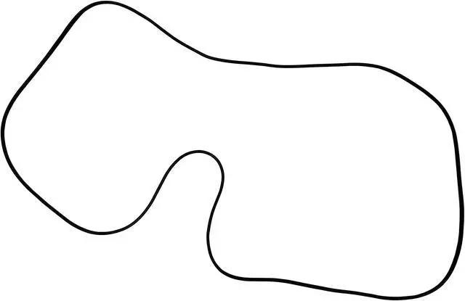
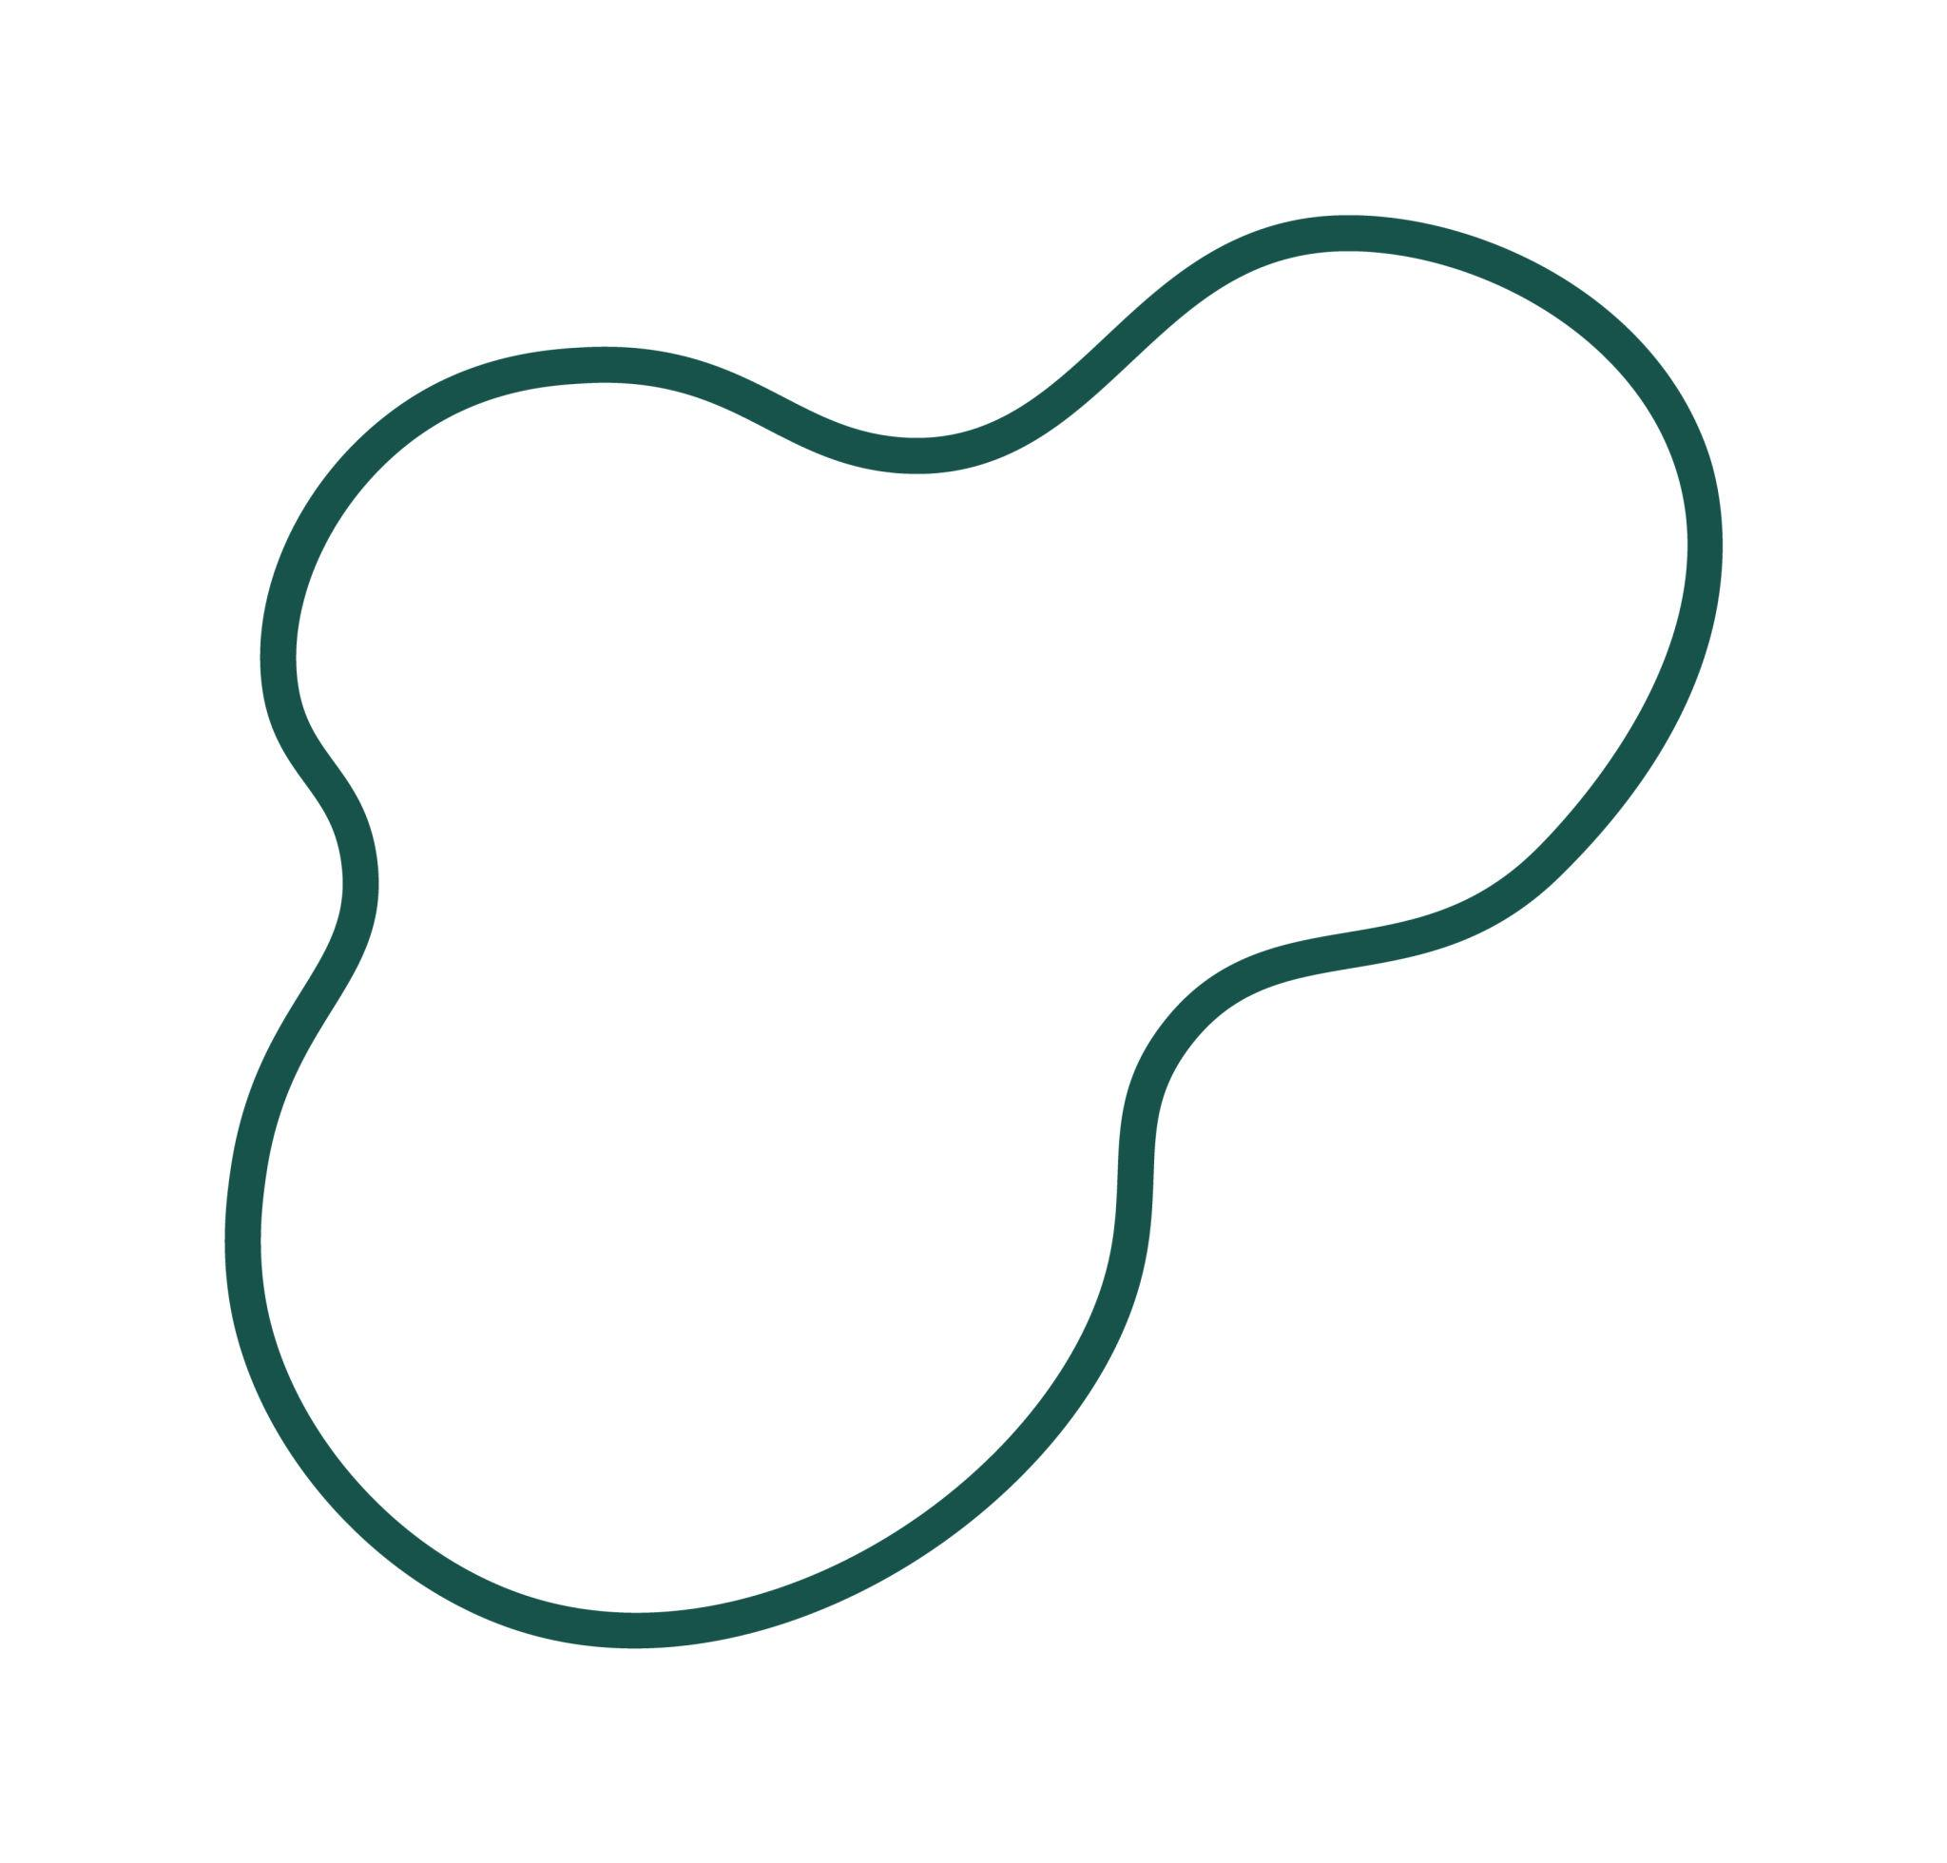
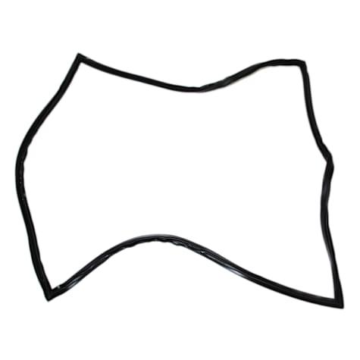
There is no regular repeating structure.

12. Artistic Circular–Freeform Open Shape
# Source: AI Source: Provided by: [Data Path: Persons Table -> ID Column: 1, Name_En Column: Motasem Essam] -> From: [ChatGPT] on [7/25/2026]
A deliberately designed open curve combining circular arcs with artistic freeform portions.
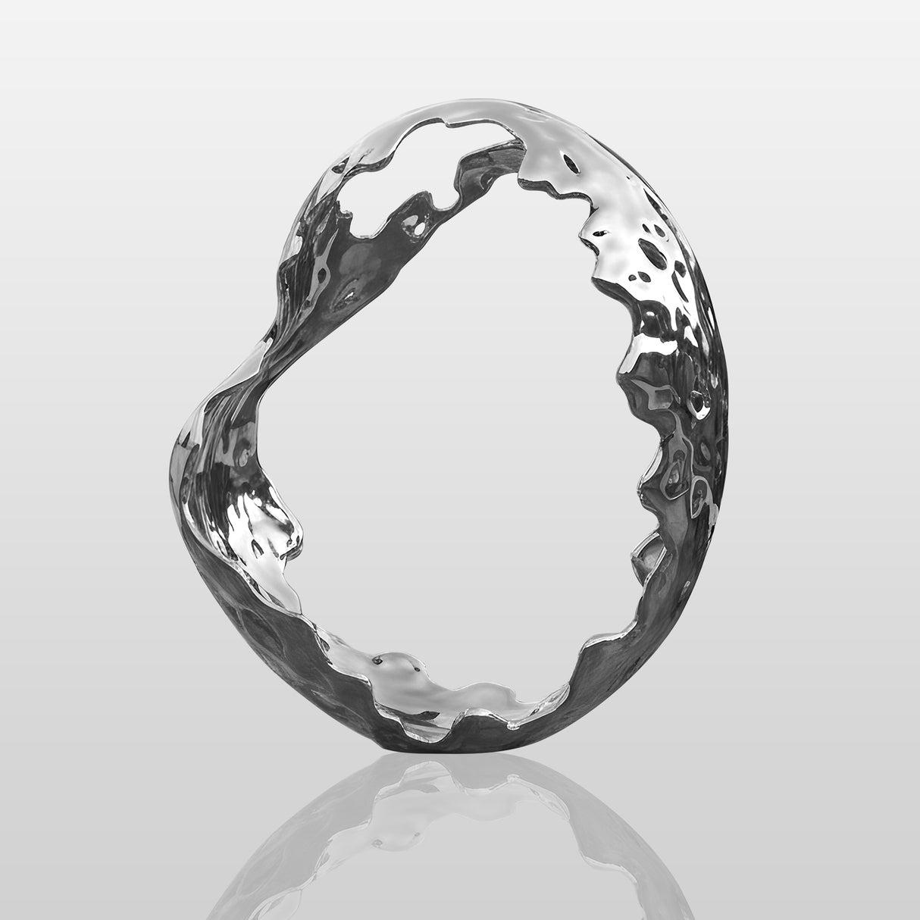
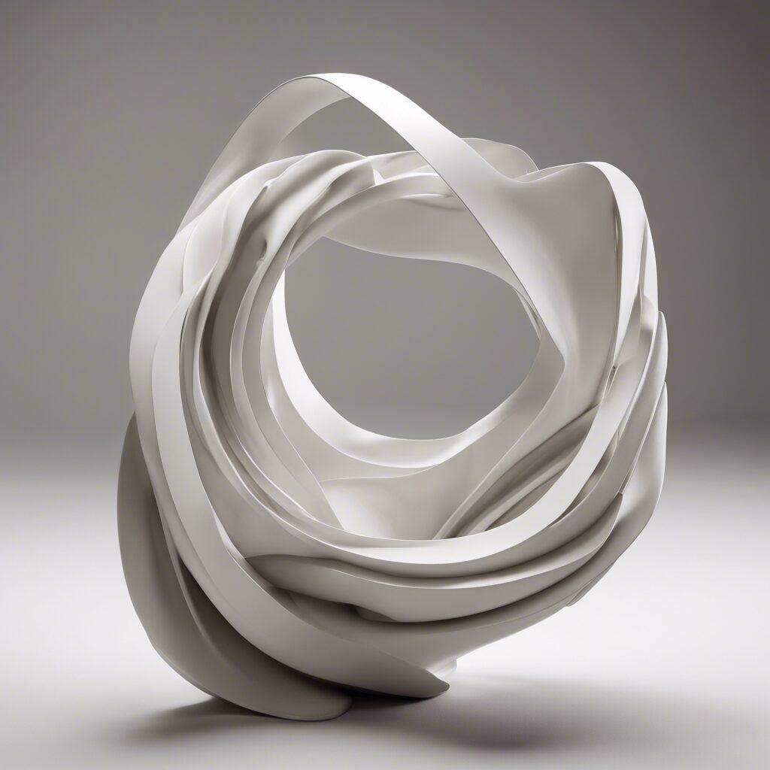
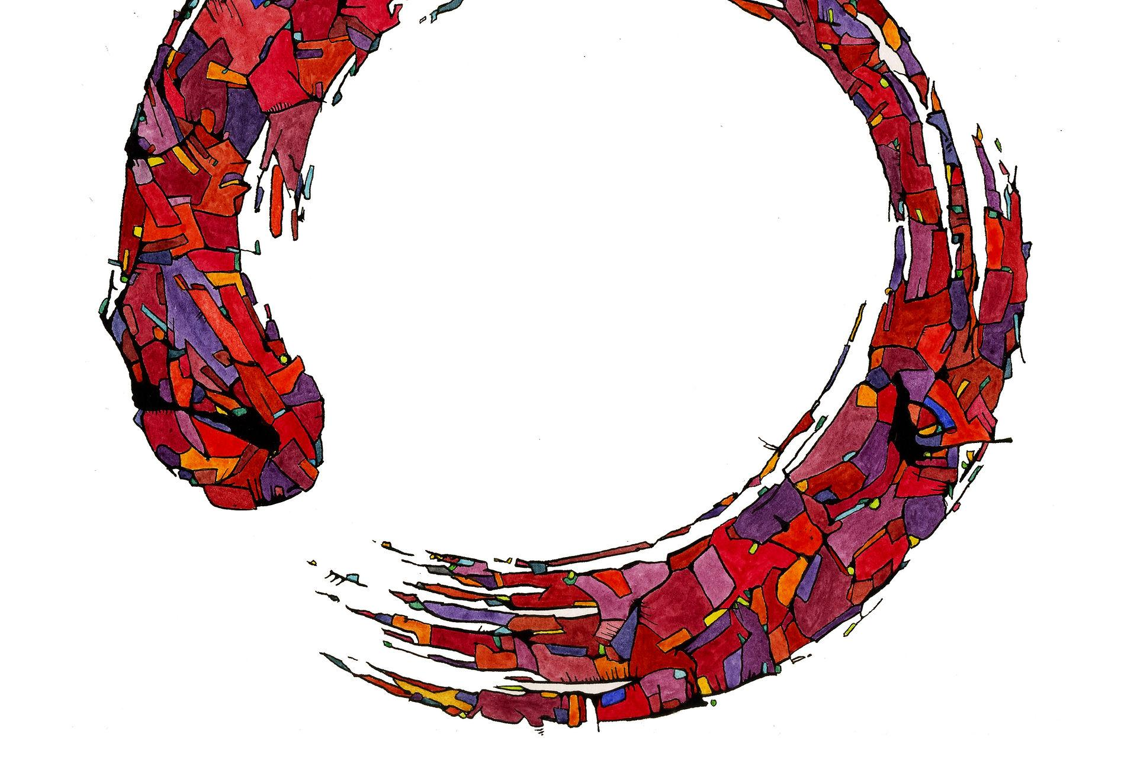
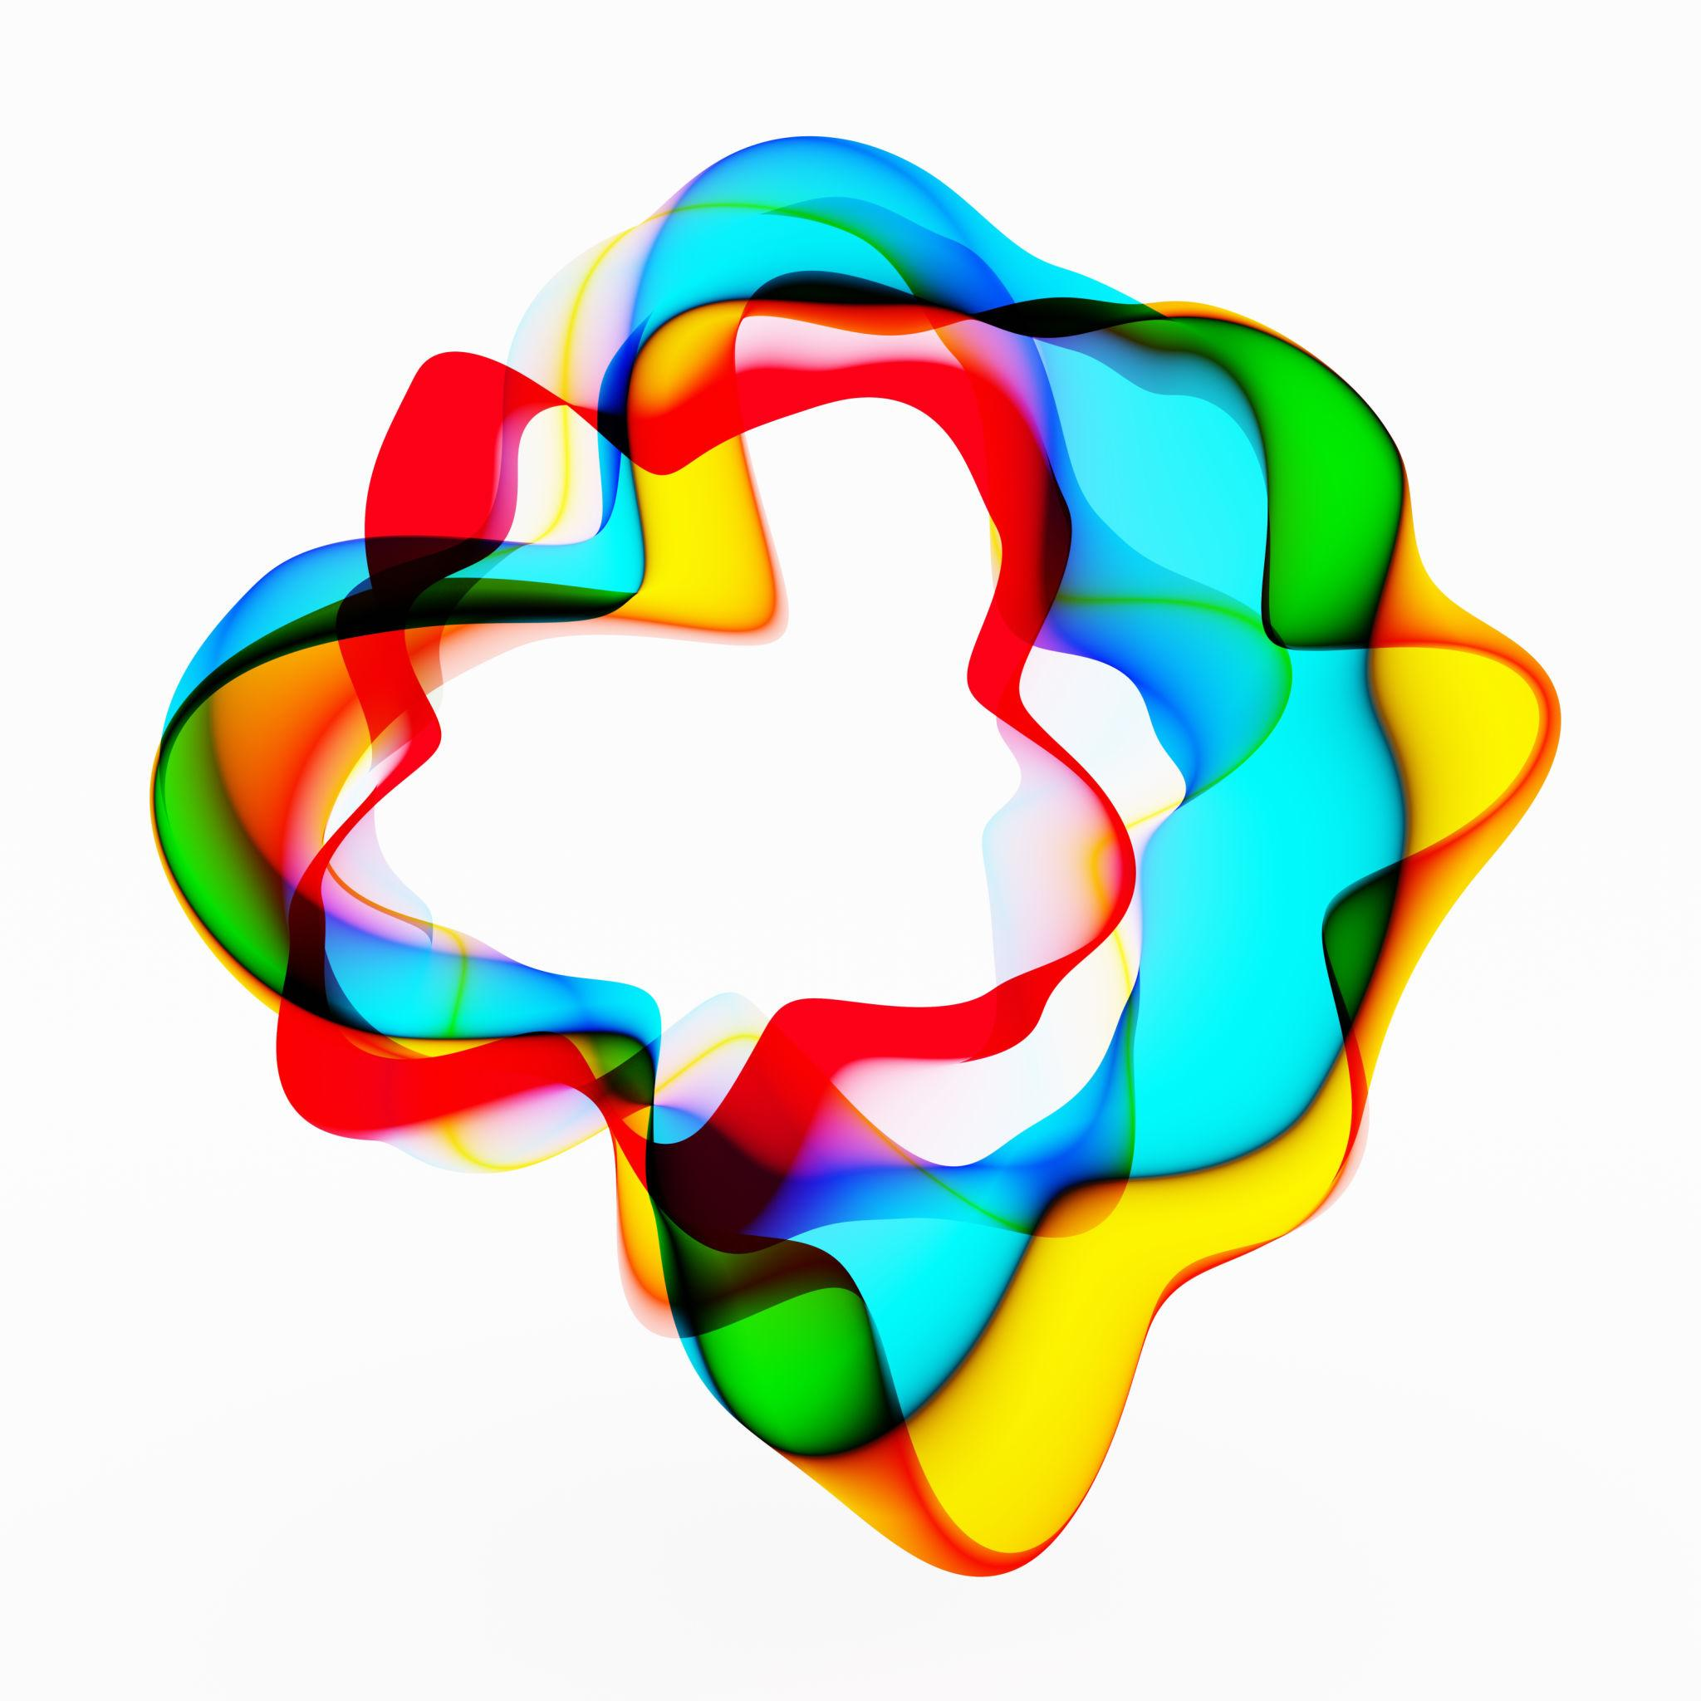
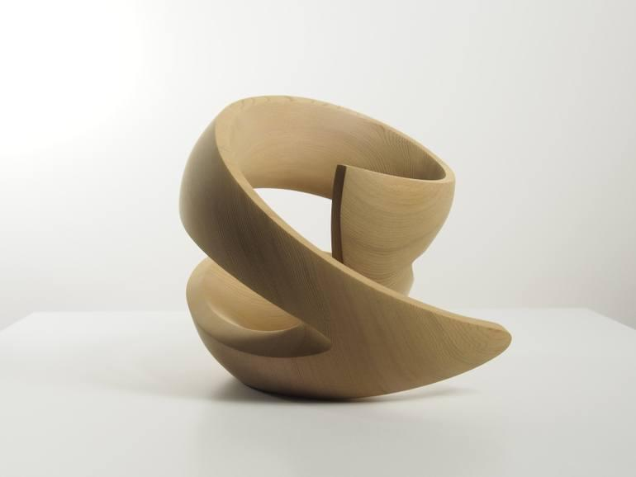
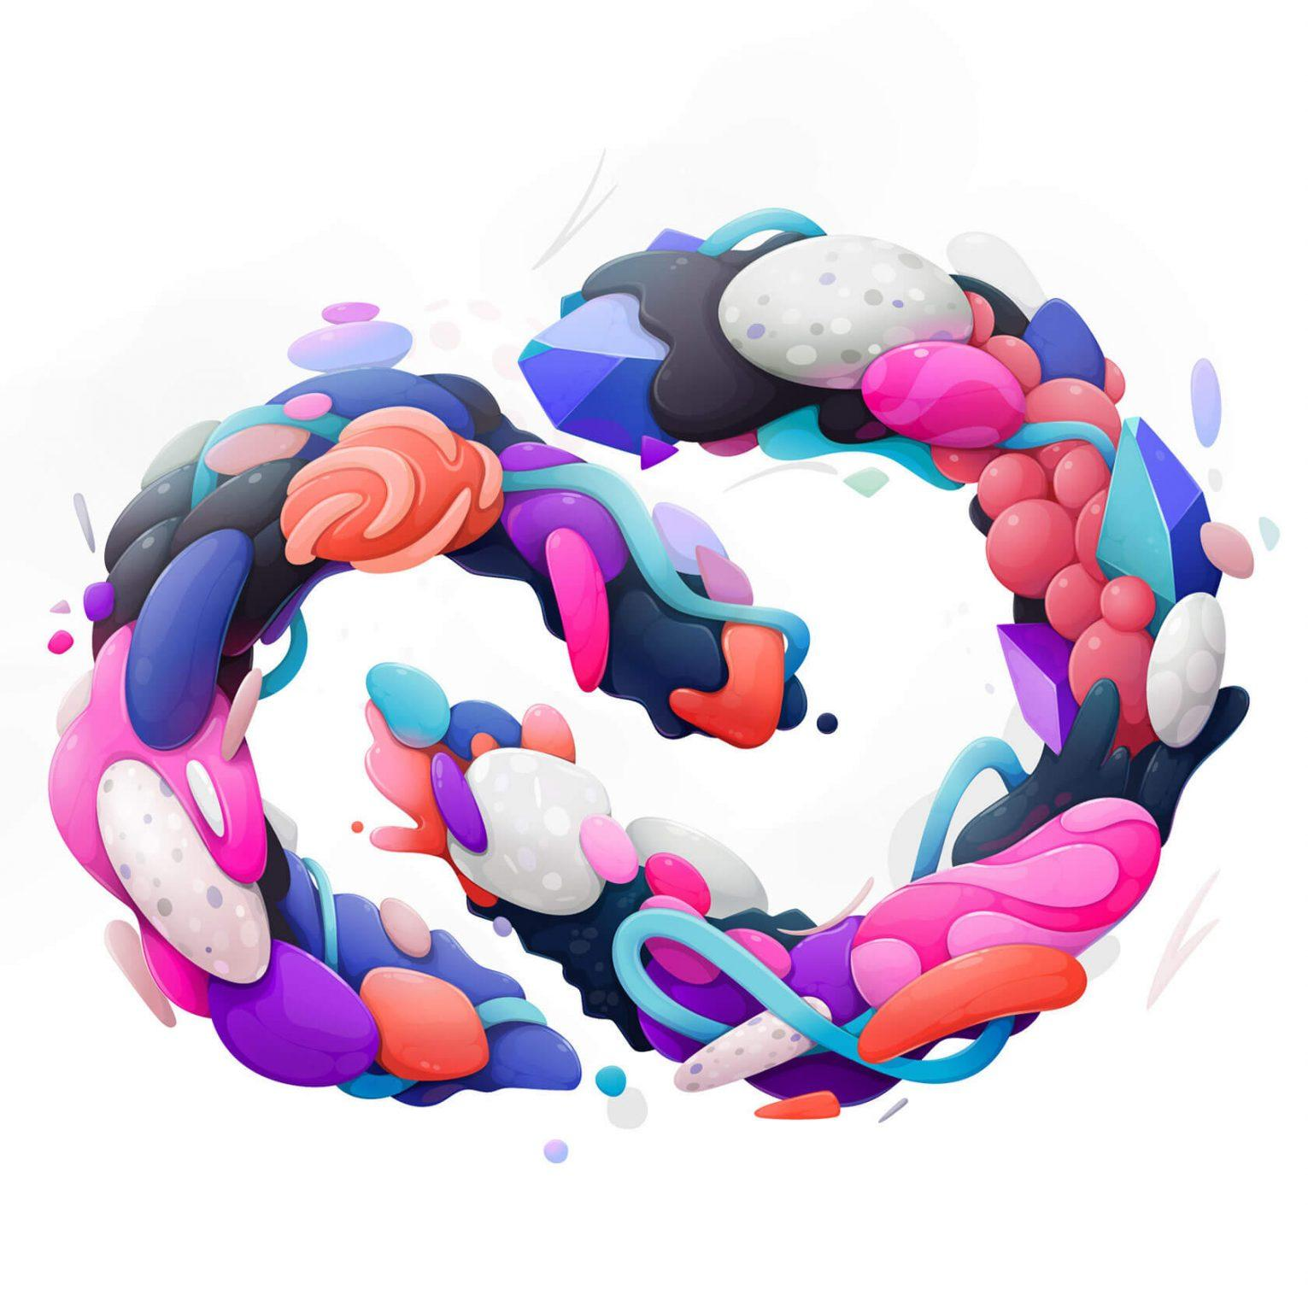
The freeform portions are controlled primarily for visual or design purposes.

Circular–Freeform vs. Circular–Organic Open Shapes
# Source: AI Source: Provided by: [Data Path: Persons Table -> ID Column: 1, Name_En Column: Motasem Essam] -> From: [ChatGPT] on [7/25/2026]
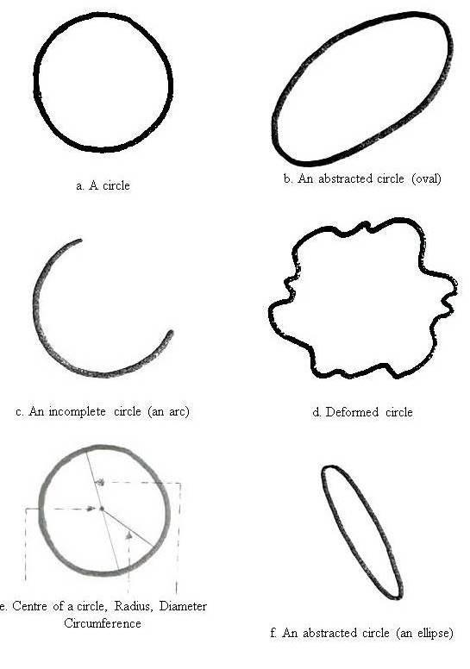
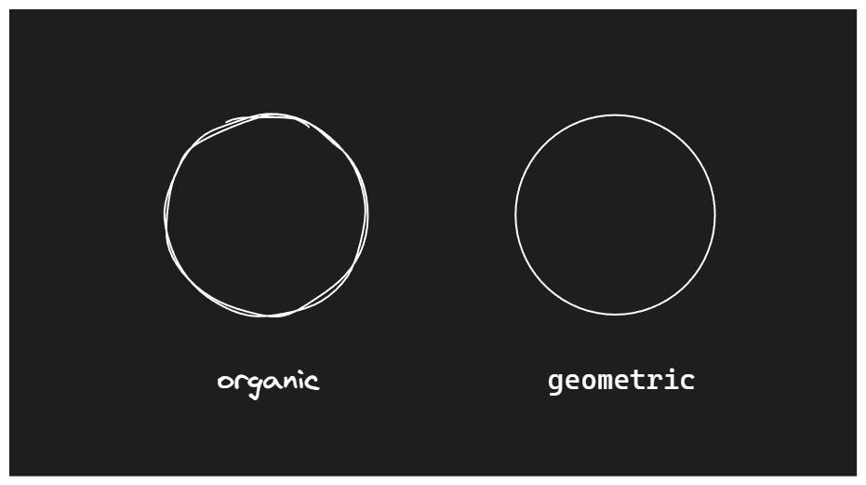
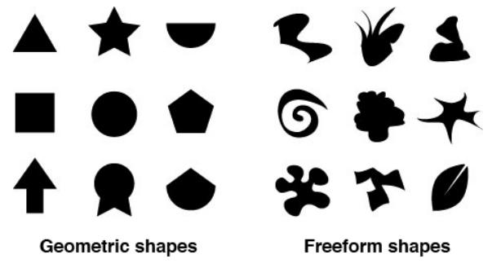
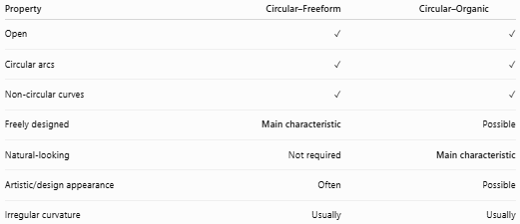
Property | Circular–Freeform | Circular–Organic
Open | ✓ | ✓
Circular arcs | ✓ | ✓
Non-circular curves | ✓ | ✓
Freely designed | Main characteristic | Possible
Natural-looking | Not required | Main characteristic
Artistic/design appearance | Often | Possible
Irregular curvature | Usually | Usually
Main distinction
$$\boxed{\text{Circular–Freeform}=\text{Circular Arc(s) + Freely Designed Curves}}$$
while:
$$\boxed{\text{Circular–Organic}=\text{Circular Arc(s) + Natural-Looking Curves}}$$

Circular–Freeform vs. Polygon–Freeform Open Shapes
# Source: AI Source: Provided by: [Data Path: Persons Table -> ID Column: 1, Name_En Column: Motasem Essam] -> From: [ChatGPT] on [7/25/2026]
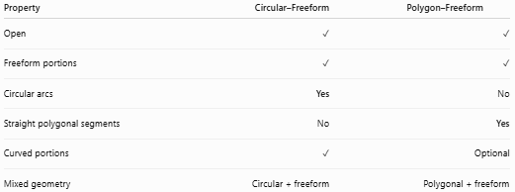
Property | Circular–Freeform | Polygon–Freeform
Open | ✓ | ✓
Freeform portions | ✓ | ✓
Circular arcs | Yes | No
Straight polygonal segments | No | Yes
Curved portions | ✓ | Optional
Mixed geometry | Circular + freeform | Polygonal + freeform

Key Points
# Source: AI Source: Provided by: [Data Path: Persons Table -> ID Column: 1, Name_En Column: Motasem Essam] -> From: [ChatGPT] on [7/25/2026]
A Circular–Freeform Open Shape is:
$$\boxed{\text{Open}+\text{Circular}+\text{Freeform}}$$
It:
- Contains one or more circular arcs.
- Contains one or more freely designed curved portions.
- Remains open.
- Has at least two endpoints.
- Does not enclose an area by itself.
- Is not restricted to a single standard geometric equation.
- May be smooth, cornered, wavy, spiral-like, irregular, or artistic.
- Can be symmetric or asymmetric.

Conclusion
# Source: AI Source: Provided by: [Data Path: Persons Table -> ID Column: 1, Name_En Column: Motasem Essam] -> From: [ChatGPT] on [7/25/2026]
Circular–Freeform Open Shapes combine the precise geometric structure of circular arcs with freely designed curved portions. The circular parts retain the geometric properties of circles, while the freeform parts can have arbitrary curvature and shape. The key distinction is that freeform describes how the non-circular portions are designed, whereas organic describes a natural-looking appearance.

